Q1:
CFG1
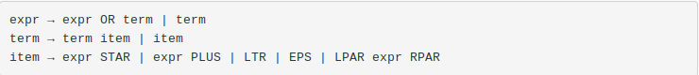
The CFG is ambiguous , for example a|b* have two different parse trees.
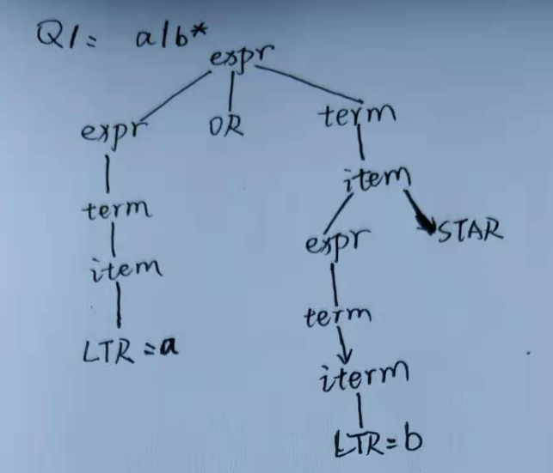
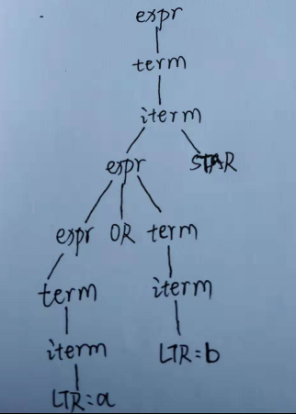
CFG2
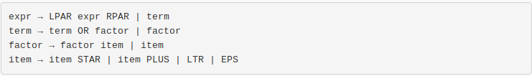
case a : (a|b)abc(a*|b+) is a legal regular expression , but is not in the language of the CFG.

CFG3
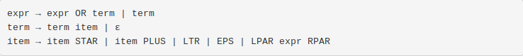
case b: a| is not a legal regular expression , but is in the language of the CFG.

CFG4
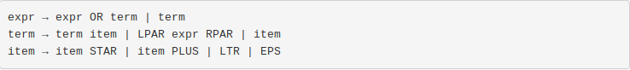
case a : (a|b)* is a legal regular expression , but is not in the language of the CFG.

CFG5
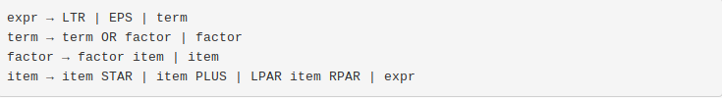

The CFG is ambiguous, for example a single LTR(a) can have two different parse trees. Because expr have a loop expr → term → factor → item → expr , however it just can be itself expr , which is ambiguous.
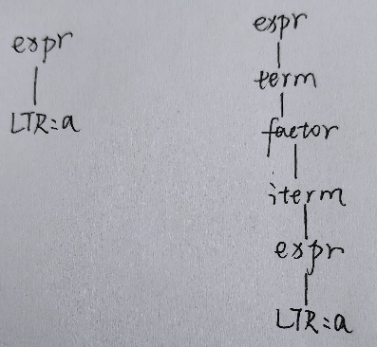
Q2:
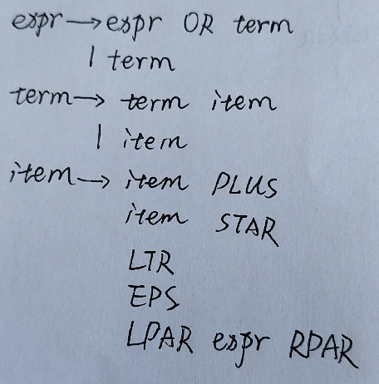
Q3
x+(y*|a+d)f+|ε

